Expanding Our Toolkit to Better Serve Citizens: Lessons Learned from Overdose Prevention Sites Across the U.S.
Roderick Bullard, Master of Public Policy Program, Michigan State University

Executive Summary
The opioid epidemic has claimed nearly 1,000,000 lives across the United States since the 1990s with 2020 breaking records for the highest number of recorded opioid deaths. Most of the country experienced record-breaking deaths while the state of Michigan experienced a 19% increase in deaths during this same period. Traditional practices of treating addiction like inpatient rehabilitation have not been enough by themselves to combat this wave of death. Methadone treatment programs have also showed promise, but we need to establish other forms of meeting people where they are. Not many resources in the American toolkit do a good job of this but some countries have expanded their kits to include overdose prevention sites.
Overdose prevention sites (OPS) offer a new way of meeting people who are struggling with substance use disorder (SUD) where they are. These sites reduce rates of STI/STD transmission, collect used needles, and provide medical staff that reverses overdoses. If there is broad support from stakeholders, this is an option for reaching another segment of people struggling with SUD. This memo highlights the lessons learned from communities across the United States that are in the process of implementing pilot overdose prevention sites and recommendations that fit a Michigan context.
Context
The county is experiencing the impacts of the opioid epidemic and Michigan is not coming out unscathed. The state experienced a 19% increase in overdose deaths in 2020 compared to 2019 resulting in over 2,900 deaths reported. The Biden administration had taken a hands-off approach, for the time being, to safe injection sites, opening the door for cities and states to pilot programs and test their political and practical feasibility in an American context. The Justice department has indicated that they are open to locations by stating they are evaluating them and examining proper guardrails. States could fund short-term pilot programs to gather data on the impact of their programs and leverage this information to shift federal laws that currently prohibit them. Demonstrating that these types of programs provide effective treatment, support, and compassion, as well as positive economic impact, will offer a new option to policymakers seeking to address the nation’s growing addiction epidemic.

Analysis
An analysis of this topic was conducted by examining three units of government across the country that were the closest to bringing overdose prevention sites to their communities. At the beginning of this project the state of Rhode Island, New York City, and San Francisco appeared to be the communities in the United States that would open these locations first. The following sub-sections highlight key information for each location that was found through the process of searching through legislative material and local news articles.

Rhode Island
Rhode Island was the first state in the country to legalize overdose prevention sites in July 2021, with legislation signed by the governor authorizing a two-year pilot. A conversation with a state staffer hinted that there was no resistance due to a shared understanding of the severity of the opioid crisis in the state. Drug overdoses increased 25% in 2020 when compared to the previous year. The statute that allows for the operation of overdose prevention sites does so by allowing nonprofit organizations to operate these locations instead of the government. The bill also requires communities that would like to have overdose prevention sites to be authorized by their municipality’s governing body. This allows communities to be involved in the decision-making process to decide whether they would like to have safe injection sites in their community.
The final regulations approved in February laid out several key details for how safe consumptions sites will operate within the state. To become a license holder, which is required to operate, organizations must submit proof of a municipality agreeing to host the safe consumption site. They must also provide a list of all owners of the organization, submit a plan jointly created with their host to address public safety and order around the center, and go through an inspection from the Rhode Island Department of Health (RIDOH). The regulations also have various stipulations for how programs develop client criteria, and programs must at least provide: drug consumption services, harm reduction education, appropriate referrals, and needle exchange programs.

New York
New York City made headlines by opening the first authorized overdose prevention sites in the country in November of 2021. New York City currently has two overdose prevention sites, with two more locations coming later this year. This project was able to get off the ground quickly by merging with existing syringe exchange programs. This not only reduced the time it took to make the sites operational, it also reduced the cost of the locations. Preliminary information indicates that almost 900 people have visited the locations more than 10,000 times since November. In addition to this they have reversed almost 200 overdoses. Planning for safe consumption sites in the city goes back to a feasibility report published by the city in 2017. Mayor Bill De Blasio led the call for this project and Mayor Eric Adams continued to oversee it upon taking office. This continued support between administrations allowed New York to quickly meet the needs of its community members. This is drastically different than San Francisco and its path towards overdose prevention sites.

San Francisco
San Francisco’s path towards creating overdose prevention sites has stalled compared to the other two cases mentioned in this section. The New York City feasibility report indicated that conversations to authorize safe consumption sites happened in 2018 with plans to open their doors later in the year, however the funding allocated from proposal C got wrapped up in the courts until 2020. In 2018 San Francisco passed proposition C via a citizens’ campaign. The proposal would on average increase taxes by .5% on local businesses that made more than $50 million in revenue. This would generate around $300 million to be used for homelessness services in the city. The money would be used to pay for affordable housing projects and projects to address the mental health needs of their citizens. Of this $300 million at least 25% must be allocated and used for the creation of new mental health programs. The proposal passed during the 2018 election cycle with more than 60% of local voters supporting the initiative. The proposal was not put on the ballot by the legislature and instead came from a citizen’s initiative, so it only needed a simple majority of votes to pass. However, some stakeholders argued that tax required a 2/3 majority to pass, and this caused the funding to become mired in litigation for several years. The funding was freed from judicial grips in late 2020 and can now be utilized but this has caused a substantial delay in introducing safe consumption sites in San Francisco.

What Can We Learn from Our Peers?
The lessons learned from the three communities studied in this project can be summarized succinctly by the following graphic:

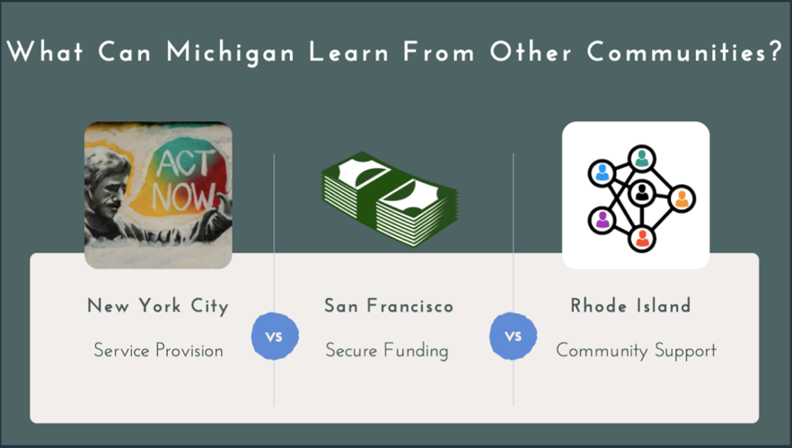

Each unit of government focused on and took 3 different approaches to addressing overdose prevention sites in their community. New York City focused on providing immediate service to the city’s residents; San Francisco focused on securing funding for these locations while Rhode Island created a process that is built on community support and engagement. The different methods taken by each government has led to different results with their own pros and cons. By focusing on service provision New York City was able to create locations quicker than other leaders throughout the country however there do not appear to be guidelines for how they operate that are accessible to the public. Rhode Island went through the process of amending their Public Health Code and creating rules and regulations. This allowed them to build a community engagement piece into their legislation to make sure that residents had a voice in these tools coming to their community. Although this created a formal structure for the implementation of OPSs the process is slower than that of NYCs. San Francisco started their process by passing a ballot initiative that would fund overdose prevention sites, which we typically think of as the most difficult part of the process. However, San Francisco’s funding was mired in legal battles and the implementation of overdose prevention sites has been sluggish at best. Through studying these three communities Michigan can learn valuable information about how overdose prevention sites have been operated across the country.

How Does Michigan Move Forward?

The state of Michigan must engage relevant stakeholders to have open and honest conversations about the opioid epidemic. Michigan is not going to escape the increase in overdose deaths across the country and leaders must examine all tools at their disposal to address this crisis. Continuing to penalize community members for the government’s lack of tools to meet them where they are will only lead to more death. Overdose prevention sites will not end the epidemic, but it will meet a new group of people struggling with substance addiction where they are in their journeys. If the state is to properly understand the scale of this issue, we must conduct a stake holder analysis that not only examines relevant government agencies, but it also should engage citizens that have been impacted by substance use. By having meaningful dialogue about the use of this tool in Michigan communities we can expand our toolkit to meet Michigan residents where they are.

Drug Overdose Deaths | Drug Overdose | CDC Injury Center. (2022, March 29). https://www.cdc.gov/drugoverdose/deaths/index.html
Kovanis, G. (n.d.). Michigan overdose deaths spike 19% to new record. Retrieved April 28, 2022, from https://www.freep.com/story/news/local/michigan/detroit/2021/11/17/michigan-overdose-deaths-spike-new-record/8652333002/
Wakeman SE, Larochelle MR, Ameli O, et al. Comparative Effectiveness of Different Treatment Pathways for Opioid Use Disorder. JAMA Netw Open. 2020;3(2):e1920622. doi:10.1001/jamanetworkopen.2019.20622
Kovanis, G. (n.d.). Michigan overdose deaths spike 19% to new record. Retrieved April 28, 2022, from https://www.freep.com/story/news/local/michigan/detroit/2021/11/17/michigan-overdose-deaths-spike-new-record/8652333002/
Peltz, J. (n.d.). Justice Dept. Signals it may allow safe injection sites | AP News. Retrieved May 2, 2022, from https://apnews.com/article/business-health-new-york-c4e6d999583d7b7abce2189fba095011
Buhl, L. (n.d.). Rhode Island Legalizes Safe Drug Injection Sites. Retrieved May 2, 2022, from https://www.thebodypro.com/article/rhode-island-to-legalize-safe-injection-sites
Press, A. (n.d.). Rhode Island Seeks Spike of Drug Overdose Deaths in 2020. US News & World Report. Retrieved May 2, 2022, from //www.usnews.com/news/best-states/rhode-island/articles/2021-04-14/rhode-island-seeks-spike-of-drug-overdose-deaths-in-2020
Harm Reduction Centers (216-RICR-40-10-25) https://rules.sos.ri.gov/Regulations/Part/216-40-10-25 (accessed May 2, 2022).
Mayor de Blasio Announces Nation’s First Overdose Prevention Center Services to Open in New York Cit. (2021, November 30). The Official Website of the City of New York. http://www1.nyc.gov/office-of-the-mayor/news/793-21/mayor-de-blasio-nation-s-first-overdose-prevention-center-services-open-new-york
Khurshid, S. (n.d.). “Clear Proof Lives Have Been Saved”: Will New York Expand on First Overdose Prevention Centers? Gotham Gazette. Retrieved May 2, 2022, from https://www.gothamgazette.com/state/11167-new-york-city-expand-overdose-prevention-centers
New York City New York. New York City Department of Health and Mental Hygiene. (2017) Overdose Prevention in New York City: Supervised Injection as a Strategy to Reduce Opioid Overdose and Public Injection. New York City Department of Health and Mental Hygiene
Torrez, A. (2020, June 23). San Francisco supervisors unanimously approve legislation for safe-injection sites [Text.Article]. KTVU FOX 2; KTVU FOX 2. https://www.ktvu.com/news/san-francisco-supervisors-unanimously-approve-legislation-for-safe-injection-sites
Lee, G. (2019, October 17). San Francisco Measure C to fund homeless services still tied up in court [Text.Article]. KTVU FOX 2; KTVU FOX 2. https://www.ktvu.com/news/san-francisco-measure-c-to-fund-homeless-services-still-tied-up-in-court
San Francisco Proposal C 2018 Ballot Iniative. (n.d.). Retrieved May 2, 2022, from https://sfelections.sfgov.org/sites/default/files/Documents/candidates/Nov%202018/LT_C.pdf
Mojadad, I. (n.d.). Supervisors authorize first use of Prop. C homelessness funds—The San Francisco Examiner. Retrieved May 2, 2022, from https://www.sfexaminer.com/news/supervisors-authorize-first-use-of-prop-c-homelessness-funds/
Torrez, A. (2020, June 23). San Francisco supervisors unanimously approve legislation for safe-injection sites [Text.Article]. KTVU FOX 2; KTVU FOX 2. https://www.ktvu.com/news/san-francisco-supervisors-unanimously-approve-legislation-for-safe-injection-sites

